Faça a configuração da rede normalmente e depois faça as configurações abaixo:

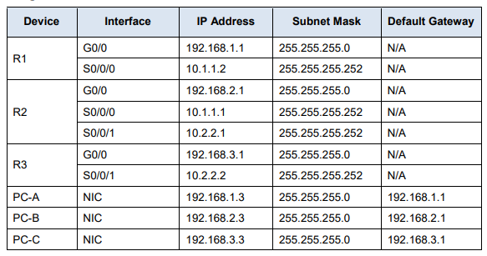

CONFIGURAÇÃO REDE ROUTER 1

access-list 110 permit ip 192.168.1.0 0.0.0.255 192.168.3.0 0.0.0.255

crypto isakmp policy 10

authentication pre-share

hash sha

encryption aes 256

group 2

lifetime 86400

exit

crypto isakmp key toor address 10.2.2.2

crypto ipsec transform-set VPN-SET esp-3des esp-sha-hmac

crypto map VPN-MAP 10 ipsec-isakmp

description VPN connection to R3

set peer 10.2.2.2

set transform-set VPN-SET

match address 110

exit

interface fa0/1

crypto map VPN-MAP

do wr

CONFIGURAÇÃO REDE ROUTER 3

access-list 110 permit ip 192.168.3.0 0.0.0.255 192.168.1.0 0.0.0.255

crypto isakmp policy 10

authentication pre-share

hash sha

encryption aes 256

group 2

lifetime 86400

exit

crypto isakmp key toor address 10.1.1.2 (outro router)

crypto ipsec transform-set VPN-SET esp-3des esp-sha-hmac

crypto map VPN-MAP 10 ipsec-isakmp

description VPN connection to R3

set peer 10.1.1.2

set transform-set VPN-SET

match address 110

exit

interface fa0/1

crypto map VPN-MAP

do wr

COMANDOS PARA VERIFICAR

show crypto isakmp sa

show crypto ipsec as